Submit Your Author Accepted Manuscript (AAM) to PsychArchives.org and Provide Early Access to Your Research
Journal: | Journal name goes here
Submission ID: | nnnn [see below how to find the Submission ID]
The Submission ID is required to link your Author Accepted Manuscript (AAM) to the announcement of your article on the journal website. Log into your journal account. You find the Submission ID on the “Submissions” page to the left of your submission’s title (see figure below).
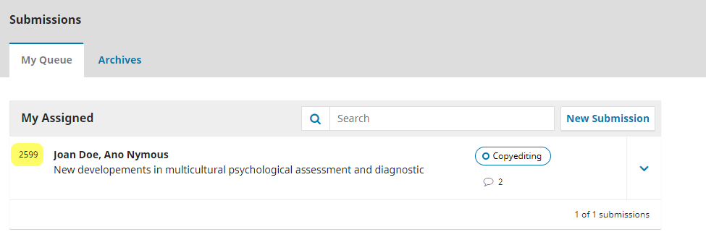
Example: Submission ID (highlighted)

Authors of the Paper
Doe, Joan; Smith, John

Title of the Paper
Title goes here

English Abstract
Abstract goes here

English Keywords
Keywords, delimited by semicolons
Keyword; Keyword; Keyword; Keyword; Keyword;

Funding (optional)
Funding goes here
The following metadata will be added by PsychArchives (do not edit):
License: | CC-BY 4.0 (URL: https://creativecommons.org/licenses/by/4.0/ )
Review status: | Reviewed
Publication status: | Accepted Version
DOI: | [DOI]
Note: The DOI of this AAM will be different from the DOI of the final article version!

Already published related documents and supplementary materials:
According to PsychOpen GOLD policy, these resources must be publicly available (open access)!

Preprint (if any)
DOI/URL of preprint

Stage 1 manuscript (for Registered Reports only)
DOI/URL of Stage 1 manuscript

Preregistration (if any)
DOI/URL of preregistration

Other supplementary materials (e.g., data, research material, scripts) (if any)
DOI(s)/URL(s) of supplementary materials

Related documents that have not yet been published will be submitted to PsychArchives.org during article production and published along with the final article version.

AGREEMENT
By sending the “Author Accepted Manuscript” (AAM) version of the article indicated above to
psycharchives-submission@leibniz-psychology.org
I confirm that (a) all information provided above is accurate and (b) I accept the “PsychArchives Terms of Use” (URL: https://www.psycharchives.org/en/about#terms).
Note: Once the AAM has been published, you can no longer change the file. However, you may upload a new version, leaving the previous version(s) publicly visible.
Type in 'AGREED' to accept PsychArchives Terms of Use:

Next steps:
- Prepare a de-anonymized, clean version of the accepted manuscript: add all author names and affiliations (one per author), remove comments and highlighting, accept all tracked changes, and include all figures, tables, etc.
Note: The required file format for your AAM is PDF, preferably as PDF/A, a PDF version designed for archiving of electronic documents. If your manuscript is in MS Word format do the following:
• Choose Save or Save As
• Change the Save as type to PDF
• Click on Options
• Check the PDF/A compliant box under PDF options and click OK
• Click Save

- Send (a) the completed AAM form and (b) the AAM document to:
psycharchives-submission@leibniz-psychology.org (Subject: AAM PsychOpenGOLD).

The final, peer reviewed version of your manuscript which has been accepted for publication but has not yet been copyedited or typeset. Please provide a clean (no comments, highlighting, etc.) and de-anonymized version of the accepted manuscript.

